THE MAHARAJA SAYAJIRAO UNIVERSITY OF BARODA

Dr. Pushpa Robin
Principal Investigator
UGC Major Project
Department of Biochemistry
Faculty of Science

FS/BC/UGC/PR/1/2013 Date. 7/3/2013

To
The Registrar,
GCU Section
M.S.University of Baroda
Vadodara.

Sub: Final Report of UGC Sponsored Major Research Project entitled “Biochemical and
biotechnological Approaches for increasing oil yield from Jatropha Curcas.”

Through: Proper Channel

Ref: F.No. 36-157/2008 (SR) date 26.3.09

GCU Ref. No.GCU/UGC/168/6/128 dated 28.4.2009

Dear sir,
Please forward three copies of the enclosed Final Report to UGC for the Major Research Project entitled “Biochemical and Biotechnological Approaches for increasing oil yield from Jatropha Curcas.” I have also attached the Statement of Expenditure and utilization Certificate and Audited statement of accounts for the entire project period.

Thanking you,
Yours faithfully,

(Dr. Pushpa Robin) Head Dean
Principal Investigator Department of Biochemistry Faculty of Science

THE MAHARAJA SAYAJIRAO UNIVERSITY OF BARODA
Dr. Pushpa Robin
Principal Investigator
UGC Major Project
Department of Biochemistry
Faculty of Science
________________________________________________________________________
FS/BC/UGC/PR/2/2013 Date. 7/3/2013

To
Jasvinder pal
Under Secretary
University Grants Commission
Bahadurshah Zafar Marg
New Delhi- 110 002.

Sub: Final Report of UGC Sponsored Major Research Project entitled “Biochemical and
Biotechnological Approaches for increasing oil yield from Jatropha Curcas.”

Ref. No.: F 36-157/2008 (SR) date 26.3.09
Dear Sir,
Kindly find enclosed herewith three Copies of Final report of the project entitled “Biochemical and Biotechnological Approaches for increasing oil yield from Jatropha Curcas.” I have also enclosed the Statement of Expenditure and Utilization Certificate duly verified by the Chief Account Officer of the M.S. University of Baroda and Audited Statement of accounts verified by the charted accountant for the entire period of the project. I request you to kindly go thorough it and close this account.

I am highly indebted to UGC for funding my project and giving me this opportunity to contribute towards science.

Thanking You,

Yours faithfully,

(Dr. Pushpa Robin)

- Biochemical and Biotechnological approaches for increasing oil yield from Jatropha curcas

Final Progress Report
(2009-2012)

Submitted to

University Grants Commission
New Delhi

By
Dr. Pushpa Robin
Department of Biochemistry
Faculty of Science
The M. S. University of Baroda
Vadodara, Gujarat – 390 002.


UNIVERSITY GRANTS COMMISSION
BAHADUR SHAH ZAFAR MARG
NEW DELHI – 110 002.

PROFORMA FOR SUBMISSION OF INFORMATION AT THE TIME OF MID TERM GROUP REVIEW WORKSHOP
(TO BE SUBMITTED IN TRIPLICATE)

- 1. UGC Reference No. and Date: F No. 36-157/2008 (SR) date 26/3/2009

- 2. Name of the Principal Investigator: Dr. Pushpa Robin

3. Address: Office: Biochemistry Department, Faculty of Science, The Maharaja
Sayajirao University of Baroda, Vadodara.
Residence: A 3, Samarpan Bungalows, Vasna Road, Vadodara -390 012.

- 4. Department and University where the project was undertaken: Biochemistry Department, Faculty of Science, The Maharaja Sayajirao University of Baroda, Vadodara.

- 5. Title of research project Biochemical and Biotechnological approaches for increasing oil yield from Jatropha curcas
- 6. Date of implementation: May 2009
- 7. Tenure of Project: 3 years from 1st May 2009 to 30th April 2012
- 8. Grants received: Rs. 11,56,000/- (Grant Approved)
: Rs. 10,91,800/-(Grant Received)
9. Objective of the project

a) Genetic characterization of the available accessions of Gujarat by using RAPD
b) Efficient micro propagation protocol with an aim of lab to land transfer of high oil yielding variety
- Alteration of male: female flower ratio to increase seed yield.

10. Methodology: (Objective Wise)
a) Genetic characterization of the available accessions by using RAPD
Plant material
Fresh and young plant tissue material from leaves and petioles were used to extract DNA using available protocols. Standardization of protocol was done using plant species grown in Department of Biochemistry, The M.S. University of Baroda, Vadodara. They were rinsed with distilled water and blotted gently on filter paper. The samples of various accessions (Table 1.1) were procured from Gujarat Agriculture University, Anand.
Table 1.1 Different Jatropha genotypes used in this study with their oil content
Sample Code | Sample Name | Seed oil%
A-2 | JCP-4, Pantnagar | 31.09
A-3 | PJA-1, Hyderabad | 32.32
A-5 | TNAU, Mettupalayam | 28.27
A-7 | TFRI, Jabalpur | 22.94
A-8 | JIP-12, Jammu | 26.12
A-9 | MSU, Vadodara | 36.36

For DNA Isolation the protocol of Keb--Llanes et al, 2002 was followed. 0.8% agarose gel electrophoresis used to separate, analyze and quantitate nucleic acids and buffer used will be 1x TAE (Tris-Acetate EDTA) buffer. DNA yield and purity were checked spectrophotometrically by measuring absorbance at 260 and 280 nm.
Restriction Digestion
In existing protocol extracted DNA sample showed higher absorbance at A260/280nm than expected. So in order to ensure good quality DNA, RE (Restriction enzyme) digestion was performed. In this method HindIII was used by varying its concentrations 2, 4, 6 and 8 Units respectively along with control (without adding enzyme) in the corresponding buffer at 37˚C for 3 h. Digested DNA along with control was analyzed by running the samples on 1% agarose gel.
DNA Amplification
37 decamer primers from Operon Technologies Inc., (USA) and Integrated DNA Technology were initially screened for their repeateable amplification with Jatropha accessions. Amplification was carried out in 25 µl reaction volumes containing 1X Assay buffer (50 mM KCl, 2.5mM of each dNTP, 0.8 µM primers, 1.5 U of Taq DNA polymerase (Banglore Genei Pvt. Ltd. India) and 20 ng of template DNA. PCR conditions were as shown below. Amplification products were separated on 1.8% agarose gel and stained with ethidium bromide and photographed under UV light.

94°C | 94°C | 38°C | 72°C | 94°C | 45°C | 72°C | 72°C | 4°C
5 min | 45 sec | 1 min | 1.5min | 45 sec | 1 min | 1 min | 10 min | store
10 cycles |  |  |  | 35 cycles

Objective b)
Efficient micro propagation protocol with an aim of lab to land transfer of high oil yielding variety
Methodology:
For Micro propogation: Jatropha curcas plants grown on University Campus were used as source of explants. Tissue culture media was per Murashige and Skoog (MS) (1962) having 30g/L sucrose. The pH of the media was adjusted to 5.6 ± 0.1 using 1N NaOH or 1N HCl and supplemented with 7g/L agar. Media was autoclaved at 15 lbps at 120ºC for 20 minutes. Growth conditions were maintained at 26+2°C with 16 h photoperiod. Young leaves at 3rd and 4th node from the apex were collected from 1.5-2 year old plants grown on campus. The explants were thoroughly washed with tap water followed by washing with soap solution. The explants were surface sterilized with 0.1% mercuric chloride for 2 to 3 minutes followed by five rinses with sterile distilled water. Leaves were then excised (1x1cm) and inoculated on MS basal medium. After a week these leaf discs were transferred to media containing different combination of BAP and IBA for regeneration. They were observed periodically and their properties were recorded. A week after inoculation on MS basal medium, the explants were cultured on (4.5 μM-27.0 μM) BAP and (3.50 μM-7.5 μM) IBA.

Objective c)
Alteration of male: female flower ratio to increase seed yield.
Methodology:
Experimental plants
For Alteration of male: female flower ratio to increase seed yield. Young plants (15 months) of Vishwamitri Railway Colony plantation, Vadodara, were selected for experiments. Gibberellic acid (GA) and 2, 4-D (2, 4- Dichlorophenoxyacetic acid) at different concentrations 10 ppm, 50 ppm, 100 ppm and 1000 ppm alone and in combination were used. The selected time of spray was the early morning hours. Equal number of sprays (approximately 5ml each) per inflorescence was applied for thrice at an interval of five days. Five plants were taken per treatment. Total flower sex ratio was calculated one week after the last spray whereas fruit yield was calculated one month after the last spray. Plants were tagged with appropriate labels. The flower development was observed till about one and half months. Fruit yield were observed for three months at an interval of one month. After each treatment dried seed were collected and weighed (Results reported are average of 20 seeds of each group). H₂O₂ extraction and estimation was carried out (Zhou et al. 2006). Dry mature seeds were analyzed for oil content (Bligh and Dyer, 1959). Fatty acid profile of oil was determined by Gas Chromatography Thin section of stem (peduncle part) was stained with Evans blue stain and observed under 40X objective of the light microscope. The statistical significance was obtained by using Student’s t-test.

Results and Discussion:
Objective a) Genetic characterization of the available accessions of Gujarat by using RAPD
The genetic difference between two individuals of a species is the basis of evolution and adaptation. Plant genetic resources comprise the present genetic variation that can be tapped for benefits to mankind and should hence be studied and conserved. There is virtually no information with regard to the number of introductions and the genetic diversity of J.curcas populations grown in India. Several researchers have attempted to define the origin of J.curcas, but the source remains controversial (Dehgan and Webster, 1979; Heller, 1996). Various PCR and PCR based techniques can be used for this. Among the PCR based techniques, RAPD is generally a preferred method. This is more so when the genome to be studied is unknown. The advantage it has over other molecular techniques is that it is less time consuming, more cost effective and the starting material (genomic DNA) requirement is low. Reports have shown that RAPD analysis can be used to detect variation within a restricted range, to identify suitable parents for linkage map construction, and for gene tagging for drought resistance (Virk et al, 1995). Very little analysis of genetic polymorphism in J.curcas has been performed so far. Protein based isozyme markers have been reported to be used to determine the genetic relatedness of the members of the genus Jatropha and Ricinus sp. (Sujatha et al, 2008). Gupta et al, 2008 used RAPD (Random Amplification of Polymorphic DNA) and ISSR (Inter Simple Sequence Repeat) markers to study different accessions of four geographical locations of India and divided them into four populations. ISSR markers have also been reported to be used to study inter and intra population variability in J.curcas (Basha and Sujatha, 2007; Senthil Kumar et al, 2009). Ganesh Ram et al, 2008 assessed the genetic diversity of 12 Jatropha species using RAPD. Irrespective of the geographical locations of different accessions and primers, it was observed that all accessions from India clustered together. Diversity analysis with local germplasm showed a narrow genetic base in India (Basha and Sujatha, 2007; Ganesh Ram et al, 2008).This indicates the need of widening the genetic base of J.curcas through introduction of accessions with broader geographical background and creation of variation through mutation and hybridization techniques (Mukherjee et al, 2011). Gupta et al, 2008 reported 40%-100% polymorphism using RAPD and approximately similar percentage polymorphism using ISSR markers in 13 Jatropha accessions from different geographical locations of India. Senthil Kumar et al, 2009 reported nearly 100% polymorphism using RAPD and ISSR markers in eight Jatropha species and three Jatropha curcas accessions. RAPD analysis in J.curcas shows a narrow genetic base (Basha and Sujatha 2007; Ganesh Ram et al, 2008).

Out of 37 primers used to study the genetic diversity of 6 Jatropha curcas accessions, 7 primers could generate reproducible amplification products. Rest of the primers resulted either in no amplification or smeared products. These primers yielded 95 amplified bands/fragments. The number of amplified fragments ranged from 1 (RAN-10, RFU-10) to 7 (RAN-3) with an average of 9.42 bands per primer (Table 1.2). The size of amplified fragments ranged from 190-3000bp (figure 1.1-1.7). Similar results have been reported by Ikbal et al, 2010 in Jatropha curcas genotypes from different states of India. Ganesh Ram et al, 2008 have reported the size of amplified products in the range of 200-2400bp for different Jatropha genotypes. Similar work has been documented by Gupta et al, 2008 in different Jatropha curcas genotypes. As shown in table 1.2, in the current study, of the 95 bands scored 66 were polymorphic whereas 28 were monomorphic. Table 1.3 shows eleven unique alleles detected with a total of five primers in five genotypes. The putatively similar bands originating for RAPDs in different individuals may not necessarily be homologous, although they may share the same size in base pairs (Gupta et al, 2008).
The pairwise comparison of the RAPD profiles based on both shared and unique amplification products was made to generate a similarity matrix. As shown in table 1.4 Jaccard’s similarity coefficient varied from (0.34 – 0.66). This narrow range of similarity co-efficient value suggests a close genetic population. This could be due to the fact that Jatropha is not a cultivated variety and has been propagated randomly throughout India. The highest value of similarity coefficient (0.66) was detected between JIP-12 and JCP-4 and PJA-1 respectively. The lowest value of similarity coefficient (0.345) was detected between accessions from Jammu (JIP-12) and TNAU (Mettupalayam). This also explains the geographical conditions playing a decisive role as the climatic conditions of both the places are different. Cluster analysis based on Jaccard’s similarity coefficient generated a dendogram (figure 1.8) which depicts the overall genetic relationship among the genotypes studied. Two distinct clusters could be observed. Genotypes JIP-12 and TNAU which show a low similarity coefficient are also placed in different clusters. Ecological and geographical differentiation are two important factors which influence breeding and sampling strategies of tree crops which further help in understanding the population structure. Variation in genetic diversity within species is usually related with geographic range, mode of reproduction, mating system, seed dispersal and fecundity (Ikbal et al, 2010). The genetic diversity observed between the genotypes in the present investigation could be due to all the above mentioned factors. Similar conclusions have been drawn by Ikbal et al, 2010, Gupta et al, 2008.

Table 1.2 Amplified DNA bands and polymorphism generated in J.curcas genotypes
Primer  (Sequence 5’- 3’) | Total  Bands | Polymorphic  Bands | Monomorphic  Bands
 | 18 | 15 | 3
  RAN-3
  GGC ACG TAA C
RAN-10 | 9 | 8 | 1
  GTG CCC GAT G
RAN-14 | 9 | 2 | 7
  TCG CCG CTT A
RFU-6 | 9 | 3 | 6
  CCT GGG CTA C
RFU-10 | 7 | 4 | 3
  CCT GGG TGA C
RBA-13 | 10 | 4 | 6
  CCG GCC ATA C
RBA-12 | 4 | 2 | 2
  CCG GCC TTA A
Total | 66 | 38 | 28
Mean | 9.42 | 5.42 | 4

Table 1.3 Primers showing amplification of unique alleles of different genotypes of J.curcas
Primer | Total Bands | No. of unique alleles | Allele size  (bp) | Genotypes
RAN-3 | 18 | 5 | 190, 210 & 450 | JCP-4
RAN-10 | 9 | 2 | 220 & 700 | TFRI
RAN-14 | 9 | 1 | 230 | JCP-4
RAN-3 | 18 | 1 | 320 | MSU
RBA-13 | 10 | 1 | 570 | MSU
RAN-13 | 18 | 1 | 580 | TFRI
RAN-14 | 9 | 1 | 750 | PJA-1
RFU-10 | 7 | 1 | 1000 | JIP-12

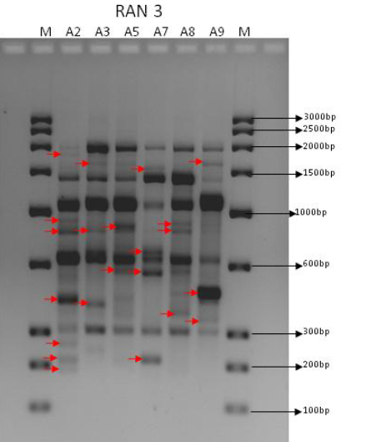
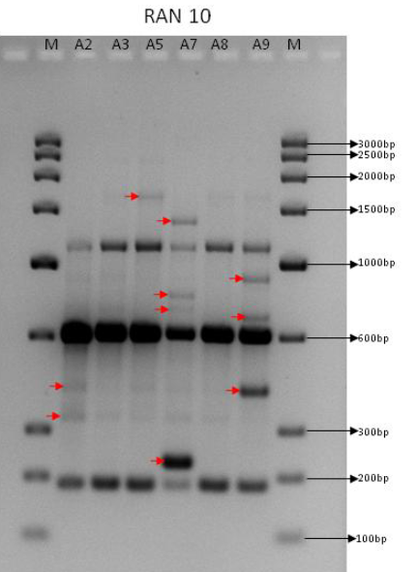
Figure 1.1: RAPD profile generated with RAN3 Figure 1.2: RAPD profile generated with RAN10

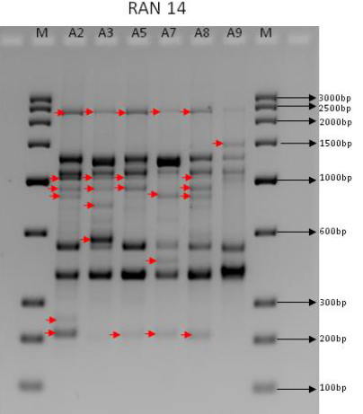
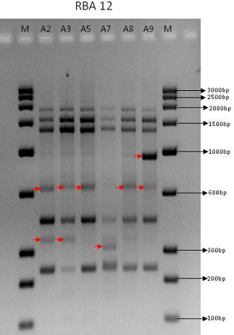
Figure 1.3: RAPD profile with RAN14 Figure 1.4: RAPD profile with RBA14
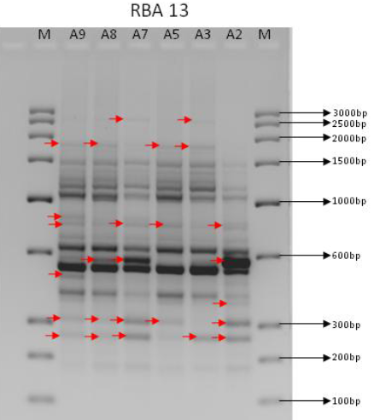
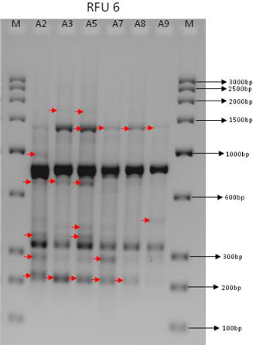

Figure 1.5: RAPD profile with RBA13 Figure 1.6: RAPD profile with RFU6
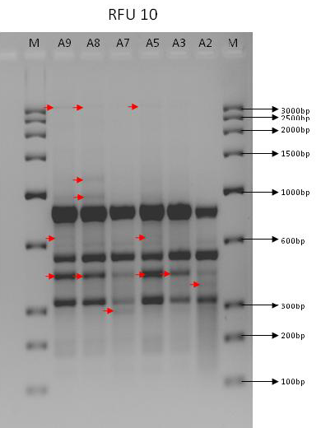
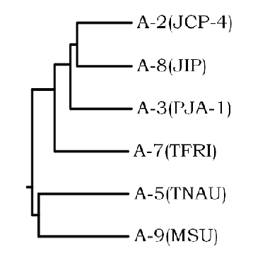
Figure 1.8 Phylogenetic tree analysis
Figure 1.7: RAPD profile with RFU10
Table 1.4 Jaccard’s similarity matrix of 7 Jatropha curcas accessions
 | JCP-4 | PJA-1 | TNAU | TFRI | JIP-12 | MSU
JCP-4 | 1 | 0.585 | 0.439 | 0.566 | 0.667 | 0.418
PJA-1 |  | 1 | 0.414 | 0.509 | 0.667 | 0.368
TNAU |  |  | 1 | 0.397 | 0.345 | 0.434
TTFRI |  |  |  | 1 | 0.549 | 0.375
JIP-12 |  |  |  |  | 1 | 0.423
MSU |  |  |  |  |  | 1
Table 1.5 Distance matrix based on Jaccard coefficient
 | JCP-4 | PJA-1 | TNAU | TFRI | JIP-12 | MSU
JCP-4 | 0 | 0.415 | 0.561 | 0.434 | 0.333 | 0.582
PJA-1 |  | 0 | 0.586 | 0.491 | 0.333 | 0.632
TNAU |  |  | 0 | 0.603 | 0.655 | 0.566
TFRI |  |  |  | 0 | 0.451 | 0.625
JIP-12 |  |  |  |  | 0 | 0.577
MSU |  |  |  |  |  | 0
Table 1.6 Distance matrix based on RMSD coefficient
 | JCP-4 | PJA-1 | TNAU | TFRI | JIP-12 | MSU
JCP-4 | 0 | 0.549 | 0.662 | 0.561 | 0.468 | 0.662
PJA-1 |  | 0 | 0.682 | 0.608 | 0.468 | 0.702
TNAU |  |  | 0 | 0.692 | 0.721 | 0.641
TFRI |  |  |  | 0 | 0.561 | 0.692
JIP-12 |  |  |  |  | 0 | 0.641
MSU |  |  |  |  |  | 0

Result And Discussion
Objective b)
Efficient micro propagation protocol with an aim of lab to land transfer of high oil yielding variety
Adventitious shoot regeneration from leaf explants was attempted. It is a known fact that a balance between auxin and cytokinin normally induces effective organogenesis. Though the nature of interaction between the two plant growth regulators is not completely understood, cell division seems to be regulated by their joint interaction affecting different phases of cell cycle. While auxins are known to exert an effect on DNA replication, cytokinin exerts some control over the events leading to mitosis. Therefore normal cell divisions would require synchrony between S phase and cell division suggesting that auxin and cytokinin levels in culture be carefully matched. Reports have shown the importance of BAP and IBA in inducing organogenesis from leaf discs. In the current investigation a range of combination of BAP (4.5 μM - 27.0 μM) and IBA (3.0 μM -7.5 μM) were used for indirect organogenesis. Curling of enlarged leaf discs was first observed followed by callus appearance at the cut margins (Figure 1). No significant difference was observed in callusing and regeneration frequency from the explants derived from 3rd and 4th expanding leaf. This is in contrast to the result reported by Sujatha and Mukta, 1996 wherein 50% regeneration was seen is leaf discs obtained from 3rd expanding leaf and 30% from the 4th expanding leaf. Callus morphology and relative response of callusing was studied. It was observed that in MS media supplemented with both BAP and IBA at highest levels i.e. 27.0 μM and 7.5 μM respectively, callus formation was very less and much slower as compared to other combinations. BAP levels as low as 9.0 μM with 5.0 μM IBA also failed to induce sufficient callus (data not shown). Explants on MS medium supplemented with lower levels of IBA (3.0μM and 5.0 μM) and higher levels of BAP gave maximum callus formation. Similar results were obtained in MS fortified with high levels of IBA in combination with low BAP. Even on sub-culturing on respective media it continued to callus. In the medium supplemented with 13.0 μM BAP + 7.5 μM IBA and 27.0 μM BAP + 7.5 μM IBA, callus turned brown and dried after first passage. By reducing IBA to 3.0 μM in combination with all three concentrations of BAP, organogenesis was observed after 45 days in culture. In the present study, tweaking cytokinin levels does not have an effect on organogenesis while low IBA levels have an influence on organogenesis. Low levels of IBA play a key role in callus formation, bud initiation and multiple shoot formation. This could be suggestive of the importance of lower levels of IBA in inducing organogenesis. Buds in clusters (3-5) started emerging from various locations of the callus, mostly underneath the explants. First bud initiation was observed in MS medium supplemented with 27.0 μM BAP + 3.0 μM IBA. It was also the most effective combination for shoot bud initiation and proliferation (Table-2.1, Figure 2). As shown in Table-2.2, there is a significant difference between all the media combinations studied except for the two containing isomolar concentration of IBA (3.0 μM) with varying BAP levels (13.0 μM and 27.0 μM). This indicates that the increased level of cytokinin fails to show its impact on initiation of organogenesis. However, after organogeneses have been successfully induced and shoot bud proliferation is observed increased IBA levels have little influence (Table-2.3). Of the four media combinations used in the study for formation of new buds, MS medium supplemented with 13.0 μM BAP +3.0 μM IBA did not show further response. However, other media combinations continued to show their effect on the number of shoot regenerants. Table-2.4 depicts the mean length of regenerants with shoot length of more than 1.0 cm. In some explants, regenerants of more than 1.5-2.0 cm were obtained (Figure 3). Number of shoots per explant is presented in Table-2.5. The MS medium supplemented with 4.5 μM BAP + 3.0 μM IBA and 27.0 μM BAP + 3.0 μM IBA are not significantly different according to DMRT (α=0.05). For the first time we report an effective combination for successful regeneration of shoots from leaf discs derived calli. It could be concluded that auxins play a greater role than cytokinins in organogenesis of J.curcas. While wide changes in cytokinin levels did not yield significant changes in shoot bud induction, a small increment in auxin levels gave rise to appreciable changes in the same. Hence, it could be concluded that irrespective of BAP levels, low levels of IBA are essential in order to obtain multiple shoot regenerants per explant. In the present study MS supplememted with 4.5 μM BAP + 3.0 μM IBA and 27.0 μM BAP + 3.0 μM IBA showed 100% frequency for callus formation, shoot bud induction and proliferation. It is a widely known fact that root formation in in-vitro grown plants is triggered or induced by external application of auxins. In the present study, rooting was observed after three weeks of transfer in the rooting medium.

Table 2.1. Effect of BAP and IBA on formation of buds
BAP/IBA(µM) | Number of buds per explant
BAP/IBA(µM) | After 6 weeks
27.0/3.0 | 10 ± 2.35 ª
13.0/3.0 | 8.0 ± 1.41ª
4.5/3.0 | 5.0 ± 0.94 ^{b}
27.0/5.0 | 2.0 ± 0.94 ^{c}
4.5/7.5 | 0.0 ± 0.0 ^{c,d}

Table 2.2. Effect of BAP and IBA on proliferation of buds
BAP/IBA(µM) | Number of buds per explant
BAP/IBA(µM) | After 10 weeks
27.0/3.0 | 9.33 ± 0.27 ª
27.0/5.0 | 8.66 ± 0.54 ª
13.0/3.0 | 6.00 ± 1.63 ^{b}
4.5/3.0 | 5.33 ± 1.90 ^{c}
4.5/7.5 | 0.0 ± 0.0 ^{d}
Means in each column followed by same letters are not significantly different according to DMRT at α=0.05 at 12 degrees of freedom.

Table 2.3. Effect of BAP and IBA on shoot length of bud regenerants
BAP/IBA(µM) | Mean shoot length | % frequency
4.5/3.0 | >1.0cm | 62.5
27.0/3.0 | >1.0cm | 55.5
27.0/5.0 | >1.0cm | 0
Shoot length of regenerants measuring more than 1.0cm only have been considered.

Table 2.4. Effect of BAP and IBA on number of shoots obtained per explant
BAP/IBA(µM) | Mean±S.E
4.5/3.0 | 4.71 ± 2.14 ª
27.0/3.0 | 4.04 ± 0.52 ª
27.0/5.0 | 1.86 ± 0.57 ^{b}
Means in each column followed by same letters are not significantly different according to DMRT at α=0.05 at 6 degrees of freedom. Data scored after 18 weeks
- Reuslts and Discussion
Objective c) Alteration of male: female flower ratio to increase seed yield.

- Fifteen months old plants were used for this study. The foliar buds of the plants were sprayed thrice at an interval of 5 days with GA and 2, 4-D at different concentrations 10, 50, 100, 1000 ppm alone and in combination. Observations were made till the fruit development was complete. GA and 2, 4-D treatment resulted in an increase in total number of flowers in a concentration dependent fashion; highest effect being observed in plants treated with GA at 1000ppm (58%). GA at 50 and 100 ppm resulted in an increase in total number of flowers by 15% and 42 % respectively (Table 5). There was a negligible increase in flower number with 2, 4-D at 50 ppm while plants treated with 2, 4-D 100 ppm showed best result with an increase of 52%. The role of GA in regulation of flowering has been well studied and molecular events involved have been deciphered. It has been shown that GA regulates the development of flowers by activation of LFY and AP1 genes. GA activates the floral meristem LFY signal which up regulates AP1 promoter results in flowering (Jack T, 2004). Thus from this study, it can be concluded that GA and 2, 4-D can be used as a potent phytohormone to increase yields from Jatropha plants.
- Apart from increasing total number of flowers and female: male ratio, GA also hastened the process of flower development. Application of GA at 1000 ppm compared to control decreased duration of flower development from 36 to 21 days as shown in Table 2. In each treatment of GA, initial three stages of flower development were faster as compared to control. Time required for the entire process of flower development was shortened by nearly 12 days. Thus, GA not only increased flowering but also enhances the rate of flower development.

- The other obvious morphological change brought about by GA application was a pronounced increase in length of peduncle (Figure 4). This effect was more in peduncle of female flowers which showed an increase of 4 and 6 folds in plants treated with 100 and 1000 ppm GA as compared to control (Table 7). The peduncle of male flower also increased in length but increase was only 1 to 2 folds respectively at 100 and 1000 ppm treatments of GA as compared to control. GA at a lower concentration (10 ppm) showed negligible effect on peduncle length. The flip side of an increase in length of peduncle was greater withering of fruits. It was observed that there was higher fruit fall in plants treated with 1000 ppm of GA as compared to 50 and 100ppm. Increased length of peduncle leads to weaker peduncle and it causes withering of fruits before it matures. It has been reported that fruit fall is a process of senescence and one of the important initiators of senescence is endogenous release of H₂O₂ which in turn results in programmed cell death (Strother S, 1988). There have been several reports which have demonstrated that GA treatment leads to release of endogenous hydrogen peroxide, a factor responsible for cell death (Bethke et al. 1999; Steffens and Sauter, 2005). On the other hand, Ethylene regulates plant cell death through generation of H₂O_{2.} GA has been demonstrated to accelerate ethylene induced cell death. However, the common signaling pathway between GA and ethylene leading to cell death is unclear (Bethke et al. 1999). Jong et al. (2002) have proposed that ethylene acts as a cofactor for H₂O₂ production by affecting phosphorylating signals which are involved in NADPH oxidase activation and catalase inhibition. Based on this, we estimated the levels of endogenous H₂O₂ to correlate PCD and fruit withering (Table 8). Plants treated with 1000 ppm GA shows 10 times higher endogenous release of H₂O₂ compared to control while no appreciable change was seen in plants treated with 10 ppm GA. Increased level of H₂O₂ is responsible for metabolic release of reactive oxygen species which leads to senescence resulting in cell death. Plants treated with GA 1000 ppm showed appreciable cell death (50% of total cells; data not shown) (Figure 8) H₂O₂ has been implicated in hypersensitive cell death by acting as a diffusible factor responsible for initiation of programmed cell death (Jong et al., 2002).

- A consequence of increase peduncle length was fruit fall. When fruit yield was calculated the highest yield was from plants treated with 100 ppm 2, 4-D as compared to 50 and 100 ppm GA (Figure 5). 2, 4-D 100 ppm shows significant good results as compared to 2, 4-D 50 ppm. Also, there was no significant change in seed weight with GA and 2 4-D treatments when compared with control. Seed weight was significantly higher in GA 50 ppm (Figure 6). The oil content in seeds showed appreciable decrease with GA treatment indicating that the fatty acid synthesis pathway is also not up regulated. The oil content in the seeds increases with 2, 4-D 100 ppm (Figure 7), which means that 2, 4-D 100 ppm increases the flux of fatty acid pathway. In conjunction with oil content, the fatty acid profile did not change by phytohormones application (Table 9). In summary, GA treatment of Jatropha curcas foliar bud increases the number of female flowers and also hastens the flower development. GA and 2, 4-D treatment on Jatropha curcas foliar bud increases the number of female flowers and fruit yield. Higher number of female flowers at 1000 ppm of GA did not translate into high fruit yield due to increased withering of immature fruits. Withering of fruits could be due to cell death mediate by H₂O₂ release at the zone of abscission and greater peduncle length. Inhibiting release of H₂O₂ which may help to decrease fruit fall and thus, translate increased female flowers to fruit yield. Fruit fall is a process of senescence which is regulated by ethylene. However, there is a good crosstalk between GA and Ethylene which mediates the senescence in plant. 2, 4-D at higher concentration increases the number of flowers and fruit yield. It would be a huge leap in per hectare production of Jatropha ensuring its commercial success. Jatropha curcas then can truly be an apt source of biodiesel.

- Table 5 Effect of GA and 2, 4-D on flower number and sex ratio in Jatropha curcas
Treatment  (ppm) | Number of Plants Treated | Number of inflorescences  observed | Total flowers in inflorescences | Total Male  flowers | Total Female flowers | Ratio  Female : Male flower
Control | 5 | 20 | 2050 ± 14.23 | 1970 ± 13.68 | 80 ± 0.55 | 1:25
GA (10) | 5 | 20 | 2512 ± 0.471*** | 2395.3 ± 91.62*** | 116.7 ± 0.472*** | 1:21
GA (50) | 5 | 20 | 2358 ± 8.05*** | 2226 ± 7.48*** | 132 ± 0.57*** | 1:17
GA (100) | 5 | 20 | 3117.2 ± 0.489*** | 2923± 19.65*** | 195 ± 0.526*** | 1:15
GA (1000) | 5 | 20 | 3342 ± 0.481*** | 3097 ± 33.90*** | 245 ± 0.566*** | 1:13
2, 4-D (50) | 5 | 20 | 1740 ± 4.489*** | 1650± 4.33*** | 90± 0.21*** | 1:18
2, 4-D (100) | 5 | 20 | 3116± 12.09*** | 2920 ± 11.24*** | 196 ± 0.85*** | 1:15
GA + 2, 4-D (50) | 5 | 20 | 1982 ± 8.91*** | 1818 ± 8.36*** | 101 ± 0.56*** | 1:18
GA + 2, 4-D (100) | 5 | 20 | 1912 ± 8.49*** | 1788 ± 7.65*** | 124 ± 0.84*** | 1:15
- Values are mean ± SE, *** indicates significantly different at p<0.001 as compared to the corresponding control.

- Table 6 Effect of GA on time scale of inflorescence development in Jatropha curcas
GA Treatment | Duration (in days) for inflorescence development
GA Treatment | Initial appearance of floral bud | Distinct appearance of flower bud | Distinct Male and Female flower bud | Opening of Male flowers | Opening of Female flowers | Complete bloom
Control | 9.00 ± 0.577 | 6.333 ± 0.333 | 4.667 ± 0.333 | 6.160 ± 0.333 | 9.467 ± 0.333 | 36.20 ± 1.068
10 ppm | 5.60 ±  0.509*** | 5.80 ± 0.583*** | 3.40 ±  0.748*** | 6.40 ± 0.748*** | 6.60 ± 0.812*** | 27.80 ± 0.812***
100 ppm | 5.00 ± 0.447*** | 4.80 ± 0.374*** | 3.40 ±  0.509*** | 6.10 ± 0.871*** | 5.60 ±  1.02*** | 24.90 ± 1.02***
1000 ppm | 4.20 ± 0.374*** | 3.60 ± 0.374*** | 3.20 ±  0.583*** | 5.60 ± 1.020*** | 5.20 ± 1.249*** | 21.80 ± 1.249***

Emergence of floral bud was considered as day zero, Values are mean ± SE, *** p<0.001 as compared to corresponding control. (n=10)
- Table 7 Effect of GA on peduncle length in Male and Female flowers of Jatropha curcas

Treatment | Female flower (cm) | Male flower (cm)
Control | 0.47 ± 0.18 | 0.55 ± 0.08
10 ppm | 1.25 ± 0.14* | 0.75 ± 0.14
100 ppm | 3.25 ± 0.14*** | 1.16 ± 0.08*
1000 ppm | 3.90 ± 0.20*** | 1.41 ± 0.22*
- Mean ± SE; *, *** significantly different at p<0.05 and p<0.001 respectively as compared to control (n=20)

- Table 8 Effect of GA and 2, 4-D on endogenous release of H₂O₂ in Jatropha curcas
Treatment (ppm) | Hydrogen peroxide (µM/gm)
Control | 8.738 ± 0.3287
GA 10 | 10.61 ± 0.5916
GA 100 | 13.86 ± 0.7699*
GA 1000 | 77.87 ± 1.267***
2, 4-D 50 | 15.17 ± 0.3407*
2, 4-D 100 | 11.29 ± 0.2369

- Values are mean ± SE; *, *** indicates significantly different at p<0.05, and p<0.0001 respectively as compared to the corresponding control. (n=5)

- Figure 4 Effect of GA and 2, 4-D on peduncle length in Jatropha curcas

- 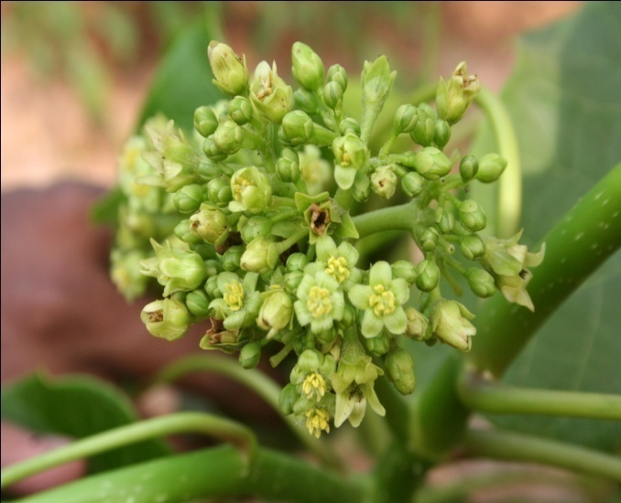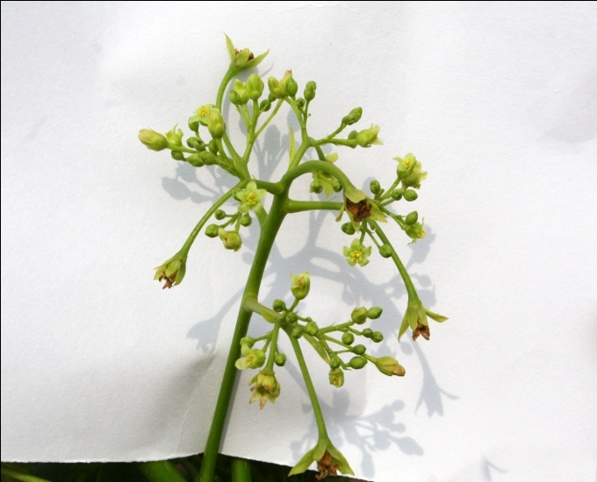
- Control GA- 100 ppm
- 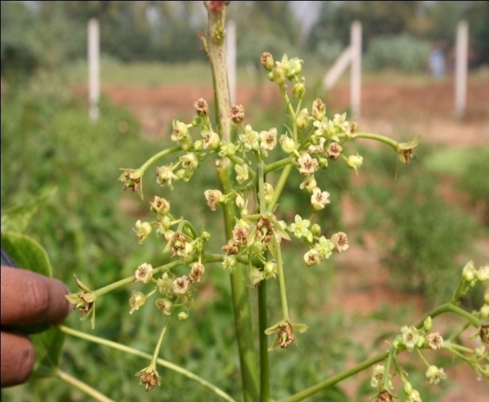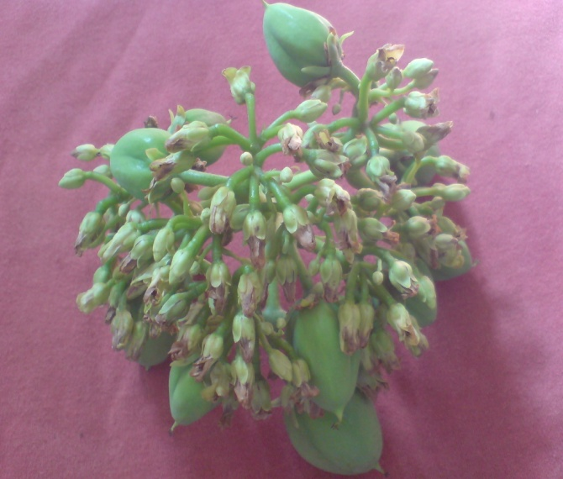
- GA- 1000 ppm 2, 4-D – 100 ppm
- The length of peduncle was measured after the end of third spray.

- Figure 5 Effect of GA and 2, 4-D on Fruit yield of Jatropha curcas
**
**
***
**
***
GA +
2, 4-D 100
- Numbers of fruits are calculated one month after third spray. Values represented is the mean of 5 replicates and bars indicate SE, **, *** indicates significantly different at p<0.01, and p<0.001 respectively as compared to control. (n=5)

- Figure 6 Effect of GA and 2, 4-D on Seed weight of Jatropha curcas

**
*
**
*

- Dried seeds of each treatment were weighed (Results reported are average of 20 seeds of each group). Values are mean ± SE; *, ** indicates significantly different at p<0.05 and p<0.01 respectively as compared to the corresponding control.

- Figure 7 Effect of GA and 2, 4-D application on Seed Oil yield of Jatropha curcas

*
**

*
**
**

**

- Dry mature seeds were analyzed for oil content by the method of Bligh and Dyer (1959). Values are mean ± SE; *, ** indicates significantly different at p<0.05 and p<0.01 respectively as compared to the corresponding control. n=5

- Table 9 Effect of GA and 2, 4-D on Fatty Acids composition of Jatropha curcas seed oil

Fatty Acids composition | Control | GA  (50 ppm) | GA  (100 ppm) | 2,4-D  (50 ppm) | 2,4-D  (100 ppm) | GA + 2,4-D  (50 ppm) | GA + 2,4-D  (100 ppm)
Myristic acid | 0.29 | ------ | ------ | 0.24 | ------ | ------ | 0.07
Palmitic acid | 11.29 | 10.41 | 11.62 | 13.28 | 12.28 | 13.28 | 14.07
Palmitoleic acid | 0.70 | 0.58 | 0.68 | 0.78 | 0.92 | 0.78 | 0.62
Stearic acid | 4.56 | 3.89 | 4.23 | 4.80 | 4.51 | 4.80 | 4.76
Oleic acid | 45.15 | 45.44 | 46.39 | 48.83 | 49.13 | 48.84 | 47.31
Linoleic acid | 37.81 | 39.35 | 36.92 | 31.74 | 32.75 | 31.74 | 32.99
Linolenic acid | 0.20 | 0.18 | 0.16 | 0.19 | 0.25  . | 0.19 | 0.19
- Fatty acid analysis from seed oil by Gas Chromatography. Values represents are Gm (%).

- Fig.8. Effect of GA on cell death of Jatropha curcas

- 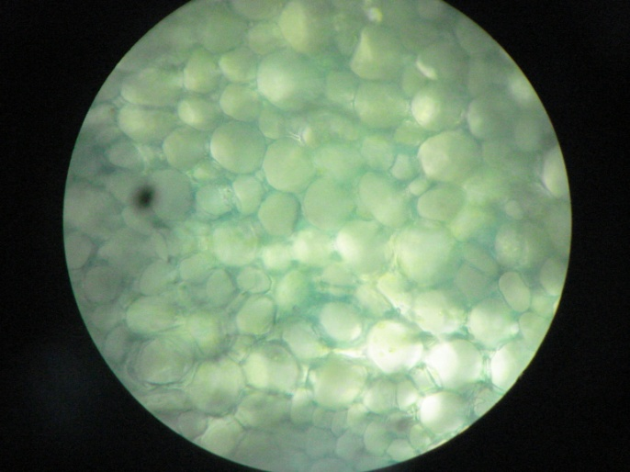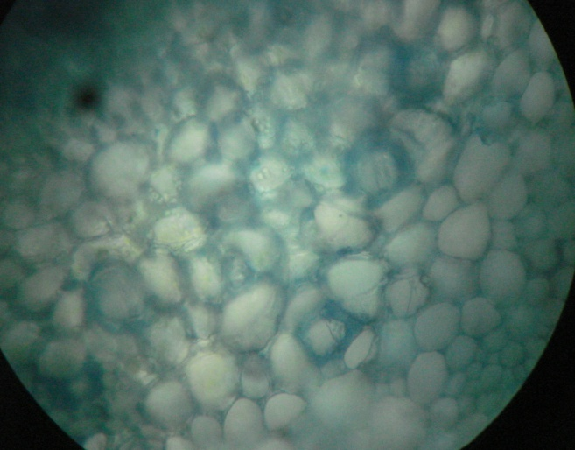
- Control GA-1000 ppm
- Thin section of peduncle was stained with Evans blue stain and observed under 40X objective of light microscope. Evans blue stains only the dead cell which appears blue in color. In the living cells the dye is reduced to a colorless form.

- 12. Work remains to be done: None

- 13. Has the progress been according to original plan of work and towards achieving objectives if not, state reasons: Work as per plan

- 14. Whether project was delayed. If yes, specify reasons: No

- 15. Please indicate the approximate time by which the project work is likely to be completed: Completed

- 16. Please indicate the difficulties, if any, experienced implementing the project: None

- 17. Collaboration, if any (Department, industry etc.): None

- 18. Ph.D enrolled, if yes, details: Yes, Mr. Vijay Makwana Reg. No. 133 dated 14th May 2008
- Phd Degree awarded in December, 2012

- 19. Details of publication resulting from the project work:
Number of publication achieved: Three (Print Attached)

- Makwana V, Shukla P, Robin P (2010) GA application induces alteration in sex ratio and cell death in Jatropha curcas. Plant Growth Regul. 61,No.2:121-125
- Makwana V, Shukla P, Robin P (2010) Comparing potential of GA and 2, 4-D in increasing fruit yield from Jatropha curcas. Journal of Biofuels. 1, No.1:157-162
- Purna Shukla, Vijay Makwana, Daksha Bhatt, Pushpa Robin (2013) Efficient
Method For Direct And Indirect Organogenesis In Biofuel Crop Jatropha Curcas:
International Journal of Pharma and BioSciences, 4(1): 673-682

- 20. Any other information which would help in evaluation of work done on the project.

- a) The results of this project can easily be applied to field to increase yield from Jatropha curcas

b) Posters presented:
1. Makwana Vijay*, Shukla Purna and Pushpa Robin: GA application induces alteration in sex ratio and cell death in Jatropha curcas, Oral Presentation at National Seminar on Biological and Alternative Energies: Present and Future, Department of Biochemistry, Andhra University, Vishakhapatnam, August 30-31, 2009. Awarded “The Best Paper” Award.
2) Makwana Vijay*, Shukla Purna and Pushpa Robin: Comparing potential of GA and 2, 4-D in increasing fruit yield from Jatropha curcas 1st International Conference on “New Frontiers in Biofuels” Indian Habitat Center, New Delhi, January 18-19, 2010
3) Shukla Purna*, Makwana Vijay and Pushpa Robin: Somatic Embryogenesis in Jatropha curcas: an attempt 1st International Conference on “New Frontiers in Biofuels” Indian Habitat Center, New Delhi, January 18-19, 2010
4) Pushpa Robin: Jatropha – Biodiesel Plant: The True Picture: Invited Lecture delivered at Mahindra United World College, Mulshi, Pune, as part of Faculty Enrichment Lecture Series, October 14, 2010.
5) Makwana Vijay, Dabhi Brijesh and Pushpa Robin: Application of GA and 2, 4-D increases flowering and fruit yield in Jatropha curcas:. Poster presented at National Conference of Plant Physiology “Physiological and Molecular Approaches for Crop Improvement under Changing Environment” held at Banaras Hindu University, Varanasi, November 25 – 27, 2010
6) Purna Shukla and Pushpa Robin: Genetic Engineering of Jatropha curcas to increase oil yield. Paper accepted for “Gordon Research Seminar” held at New Hampshrie, USA, July 28-29, 2011. Rs. 50,000 towards travel expenses sanctioned by Gujarat Government

- c) Research training imparted during the work: Nearly 15 students from The M. S. University and S. P. University have been given dissertation training in this project

- 21. Financial assistance provided/expenditure incurred for the entire project

- Sr. No. | - Items | - Amount Approved | - Expenditure incurred
- 1. | - Books/Journals | - 10,000 | - 9835
- 2. | Equipments | - 5,20,000 | - 5,12,360
- 3. | - Contingency | - 36,000 | - 35,876
- 4. | Travel/Field work | - 10,000 | - 13,728
- 5. | Hiring Services | - 36,000 | - 37,440
- 6. | Chemicals and Glasswares | - 2,00,000 | - 1,99,867
- 7. | Overhead | - 56,000 | - 56,000
- 8. | Any Other Items (Specify) | - - | - -
- 9. | Honorarium to PI (From … to …) | - - | -
- 10. | Staff (Details of staff in prescribed format Annexure IX) | - 2,88,000 | - 2,24,000
 | Total | - 11,56,000 | - 10,89,106

It is certified that the grant of Rs 10,89,106 (Ten lakh eighty nine thousand one hundred six) out of the total grant of Rs. 10,91,800 (Ten lakhs ninetyone thousand eight hundred) received from University Grants Commission under the scheme of support for Major Research Project entitled “Biochemical and Biotechnological approaches for increasing oil yield from Jatropha curcas “ vide UGC letter No. F No. 36-157/2008 (SR) date 26/3/2009 has been utilized for the purpose for which it was sanctioned and in accordance with the terms and conditions laid down by the University Grants Commission.
Date:7th March. 2013
- Place: Vadodara

Principal Investigator Head Dean
Dr. Pushpa Robin Biochemistry Department Faculty of Science

Registrar
The M.S. University of Baroda
Annexure IX
PROFORMA FOR SUPPLYING THE INFORMATION IN RESPECT OF THE STAFF APPOINTED UNDER THE SCHEME OF MAJOR RESEARCH PROJECT

UGC FILE NO. F 36-157/2008 (SR) (HRP) YEAR OF
2 | 6 | 0 | 3
- 2 | 0 | 0 | - 9
- COMMENCEMENT

- Title of research project: “Biochemical and Biotechnological approaches for
- increasing oil yield from Jatropha curcas”

- 1. | - Name of the Principal Investigator | - Dr. Pushpa Robin
- 2. | - University | - Biochemistry Department, Faculty of Science, The Maharaja Sayajirao University of Baroda, Vadodara
- 3. | - Name of the research personnel appointed | - Mr. Vijay Makwana
- 4. | - Academic Qualification | - M.Sc. 2004; 50%
- 5. | Date of Joining | - 01-06-2009
- 6. | - Date of Birth | - 25-03-1980
- 7. | - Amount of HRA, if drawn | - nil
- 8. | - No. Candidates applied for the post | - 05

CERTIFICATE
This is to certify that all the rules and regulations of UGC Major Research Project outlined in the guidelines have been followed. Any lapse on the part of the University will liable to terminate of said UGC Project.

Principal Investigator Head Registrar/Principal
Biochemistry Department The M. S. University of Baroda

